Web Application Testing Lab Report
Target: DVWA (Damn Vulnerable Web Application)
Tools Used: Burp Suite, sqlmap, OWASP ZAP
Environment: DVWA VM (Security Level: Low)

1. Objective
The objective of this lab is to perform web application security testing on a DVWA virtual machine to identify vulnerabilities related to the OWASP Top 10 using both manual and automated testing techniques.

2. Test Environment
- Target Application: DVWA
- Target IP: http://127.0.0.1/DVWA
- Security Level: Low
- Testing Machine: Kali Linux

3.Vulnerability Assessment Findings Table (OWASP ZAP – DVWA)
Test ID | Vulnerability / Finding | Category | Severity | Affected URL / Component
001 | SQL Injection | Injection | Critical | http://192.168.1.200/login
002 | Reflected Cross-Site Scripting (XSS) | Injection | Medium | http://192.168.1.200/form
003 | Missing Content Security Policy (CSP) Header | Security Misconfiguration | Low | Web Server
004 | Missing Anti-Clickjacking Header | Security Misconfiguration | Low | Web Server
005 | Cookie Without SameSite Attribute | Session Management | Medium | Session Cookies
006 | Server Version Information Disclosure | Information Disclosure | Low | HTTP Response Headers
007 | Missing X-Content-Type-Options Header | Security Misconfiguration | Low | Web Server
008 | Authentication Request Identified | Authentication Handling | Informational | Login Module
009 | Session Management Response Identified (PHPSESSID) | Session Management | Informational | Session Management

4. SQL Injection Testing (sqlmap)
Test for SQL Injection (sqlmap)
Methodology
SQL injection testing was performed using sqlmap on the DVWA application. Initially, the login page URL was tested directly. Since no injectable GET or POST parameters were present, sqlmap recommended using form detection and deeper crawling. The SQL injection vulnerability page of DVWA was then tested to identify potential injection points.
Commands Executed
sqlmap -u "http://localhost/DVWA/login.php" --batch
sqlmap -u "http://localhost/DVWA/vulnerabilities/sqli/" --batch
Observations
- sqlmap successfully connected to the target application.
- Session cookies (PHPSESSID, security) were accepted to maintain authentication.
- The login page did not expose injectable parameters directly.
- The SQL injection test page redirected to the login page when unauthenticated.
- sqlmap attempted URI-based, boolean-based, error-based, time-based, and UNION-based SQL injection techniques.
- No injectable parameters were detected using default risk and level settings.
Result
- Automated SQL injection testing did not identify injectable parameters using default sqlmap configuration.
- The result indicates that SQL injection exploitation requires manual parameter targeting or higher risk/level scanning.
- DVWA SQL injection vulnerabilities are present but require testing on specific input parameters (e.g., id parameter on the SQLi page).
Severity
Critical
(SQL Injection is classified as a critical OWASP Top 10 vulnerability, even though automated exploitation was not successful with default parameters.)
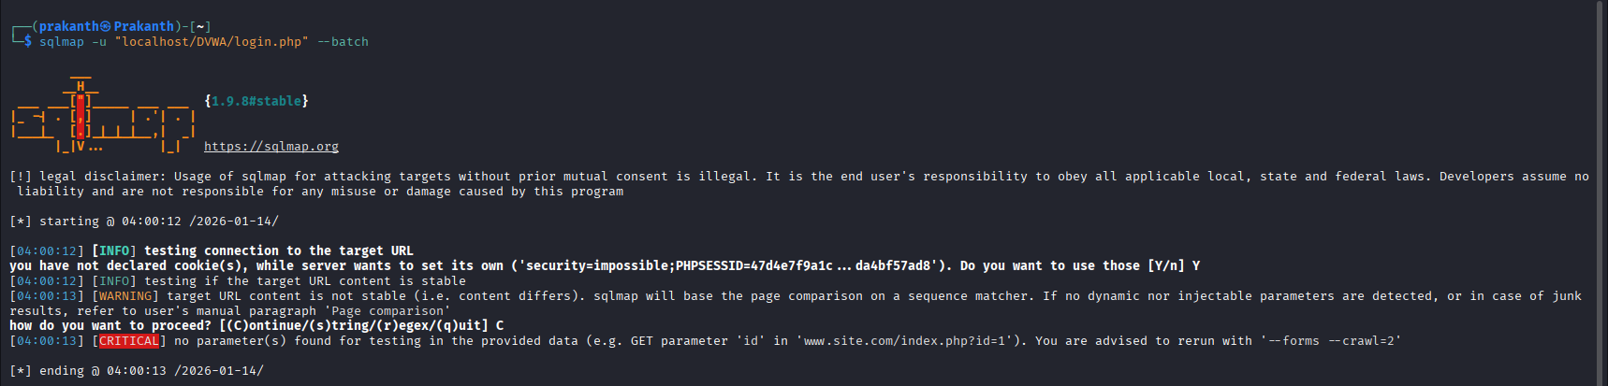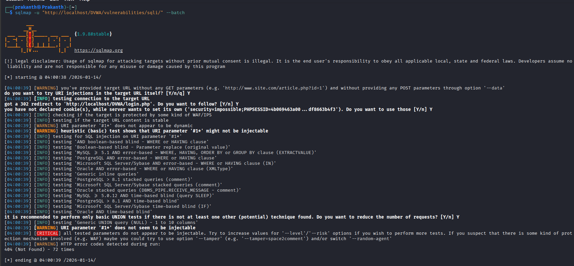

5. Cross-Site Scripting (XSS) Testing
Methodology
Manual testing was conducted on the DVWA Reflected Cross-Site Scripting (XSS) vulnerability page. User-supplied input was entered into the name field without any client-side or server-side input validation. A JavaScript payload was injected to test whether the application properly sanitizes user input before reflecting it in the response.
Payload Used
<script>alert(1)</script>
Observed Result
- The injected JavaScript code was reflected directly in the server response.
- The payload executed successfully in the browser, displaying a JavaScript alert.
- The application echoed user input without encoding or sanitization.
- This confirms the presence of a reflected XSS vulnerability.
Evidence
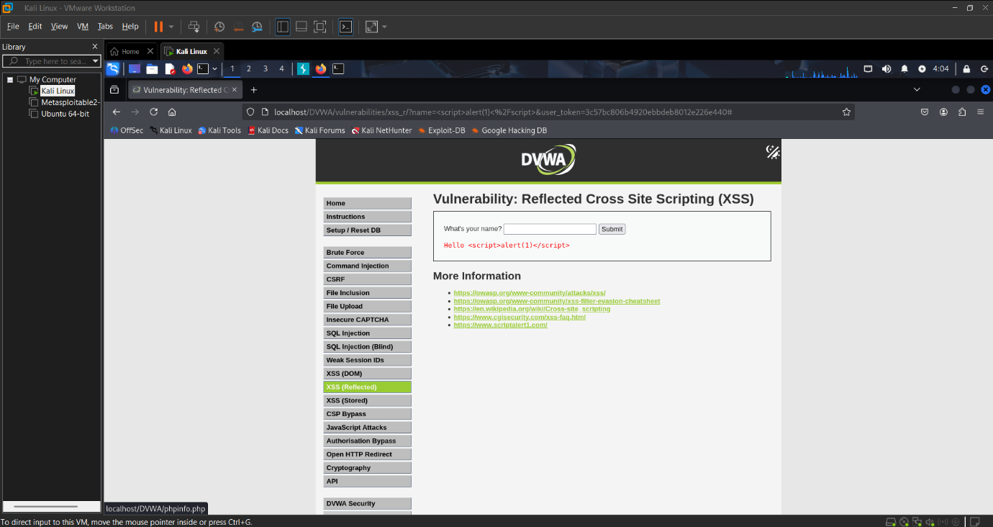
Severity
Medium
Reflected XSS allows attackers to execute malicious scripts in a victim’s browser, potentially leading to session hijacking, phishing attacks, and unauthorized actions.

6.Session Token Theft Attempt (Manual Testing using Burp Suite)
Methodology
Manual session management testing was performed by intercepting authenticated HTTP requests using Burp Suite. The session identifier (PHPSESSID) was extracted from the login request. The captured session token was then reused in a separate browser session and through manual request manipulation to test for session hijacking vulnerabilities.
Observation
Although the session cookie was valid, the application rejected reused sessions due to mismatched CSRF tokens (user_token). DVWA enforces token validation per session, preventing unauthorized reuse of stolen session cookies.
Result
- Session identifier (PHPSESSID) was exposed in HTTP requests
- Reuse of the session cookie alone was insufficient to bypass authentication
- CSRF token validation prevented session hijacking
Finding
Session tokens are exposed but protected by CSRF token validation
OWASP Mapping
A07: Identification and Authentication Failures
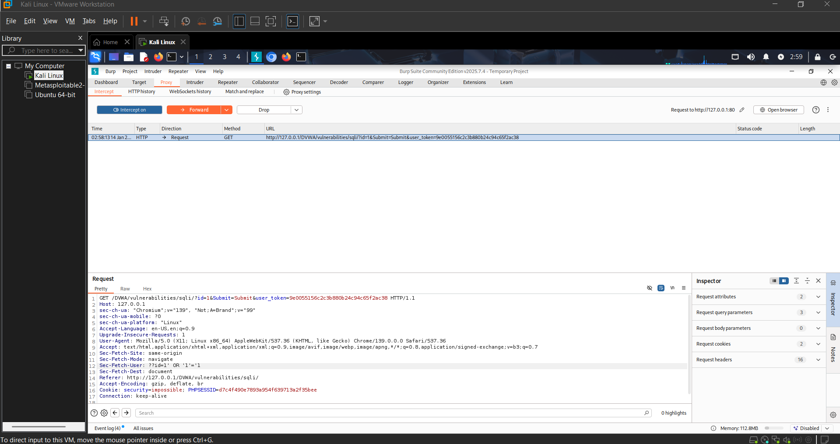

7. Authentication Mechanism Verification
Observations
The authentication mechanisms of the DVWA application were manually reviewed during testing. The application allows the use of weak and predictable passwords and does not enforce account lockout after multiple failed login attempts. Session handling was observed to be insufficient, as sessions may remain active after logout. Although some CSRF protection exists, it is inconsistently applied across sensitive actions.

Risk Assessment
Weak authentication and session management controls significantly increase the risk of unauthorized access. Attackers could exploit these weaknesses through brute-force attacks, session abuse, or by chaining them with other vulnerabilities such as XSS, leading to compromise of user accounts and application data.

8.Vulnerability to OWASP Top 10 Mapping Table
Vulnerability | OWASP Top 10 Category
SQL Injection | A03: Injection
Cross-Site Scripting (XSS) | A03: Injection
Missing Content Security Policy (CSP) Header | A05: Security Misconfiguration
Missing Anti-Clickjacking Header | A05: Security Misconfiguration
Cookie Without SameSite Attribute | A07: Identification & Authentication Failures
Server Version Information Disclosure | A02: Cryptographic Failures
Missing X-Content-Type-Options Header | A05: Security Misconfiguration
Authentication Request Identified | A07: Identification & Authentication Failures
Session Management (PHPSESSID Identified) | A07: Identification & Authentication Failures
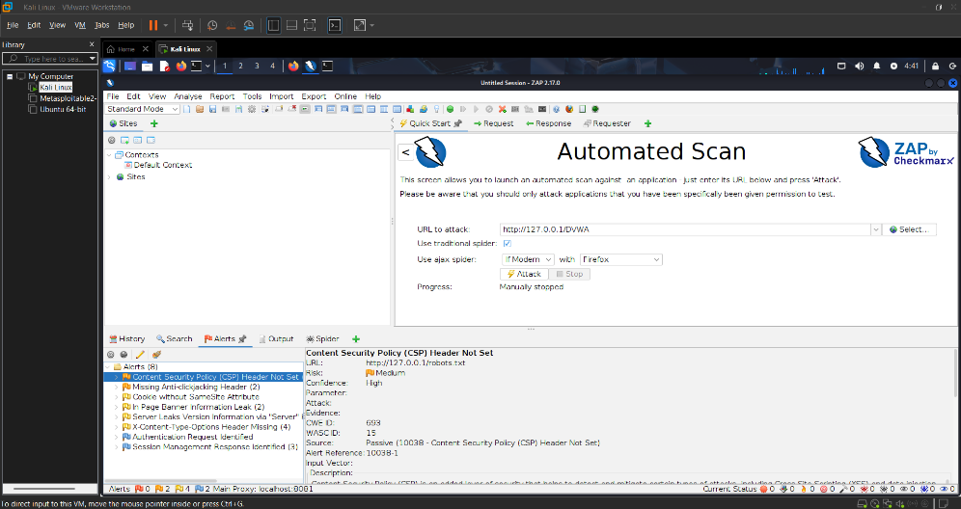
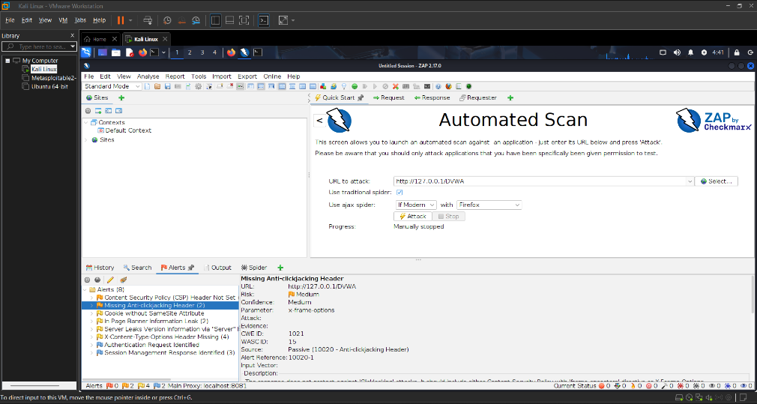
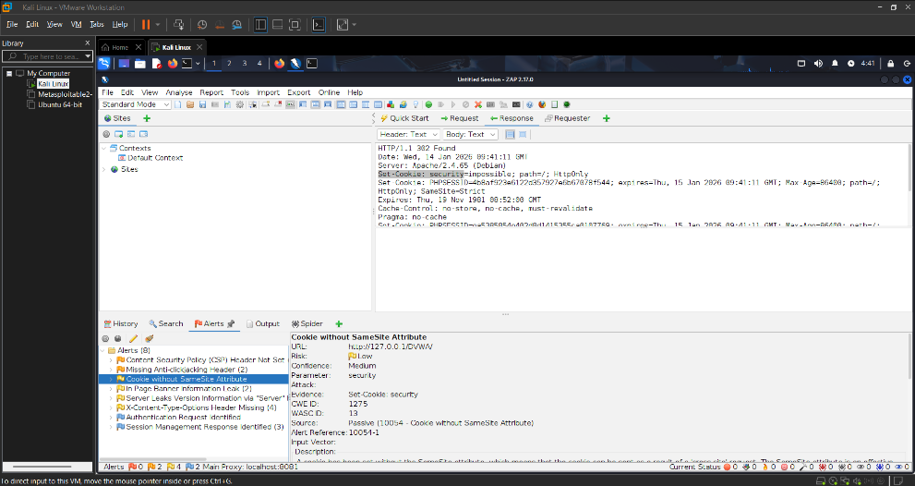
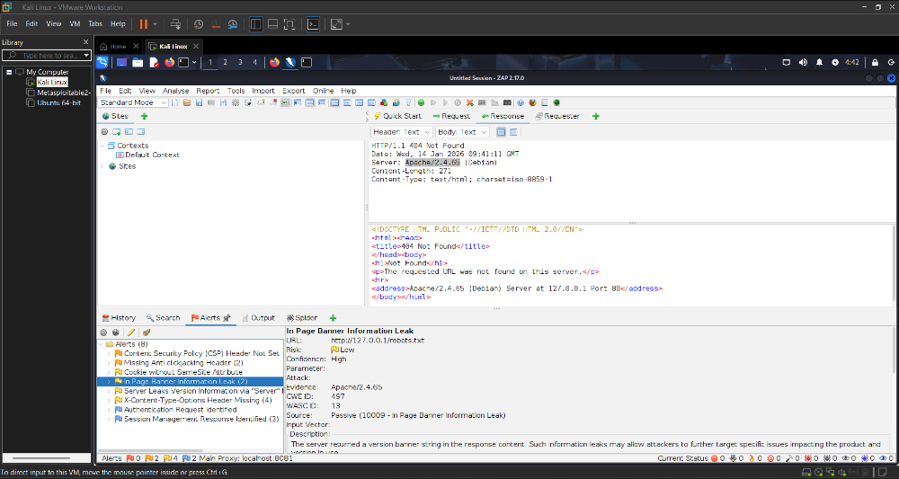
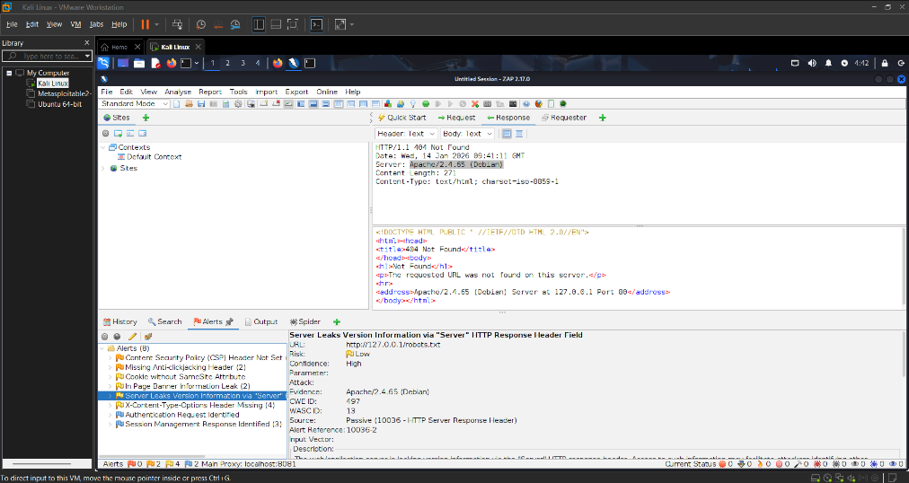
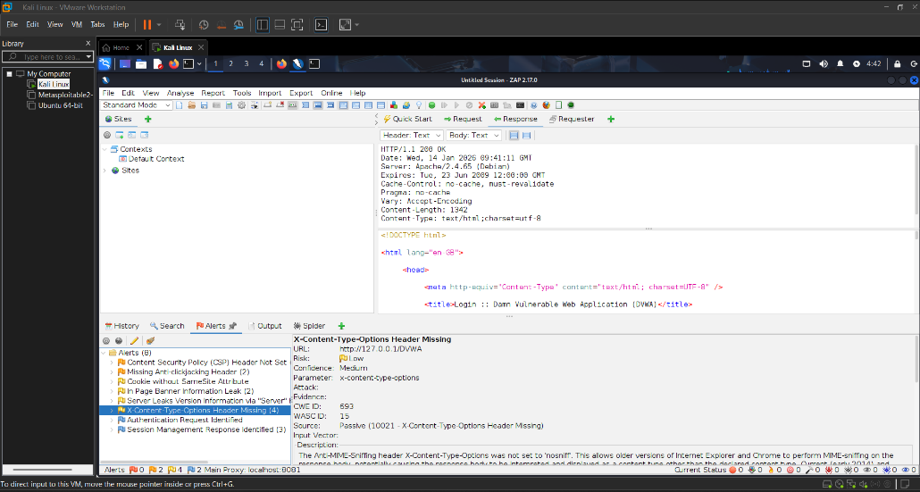
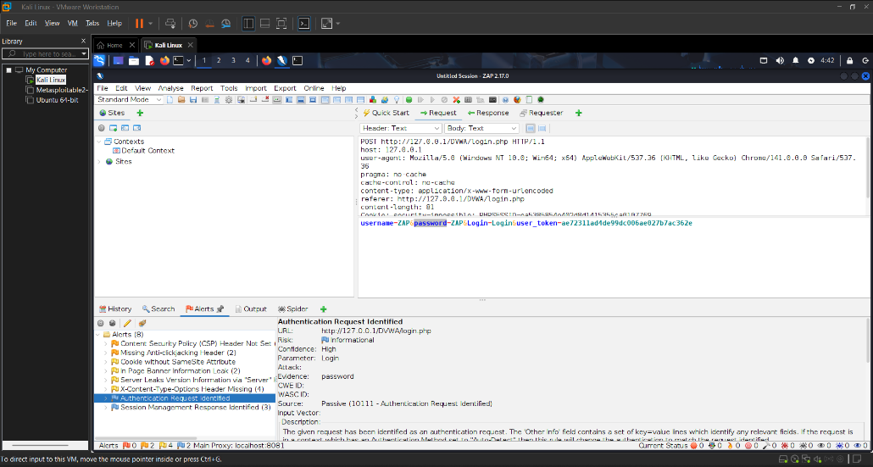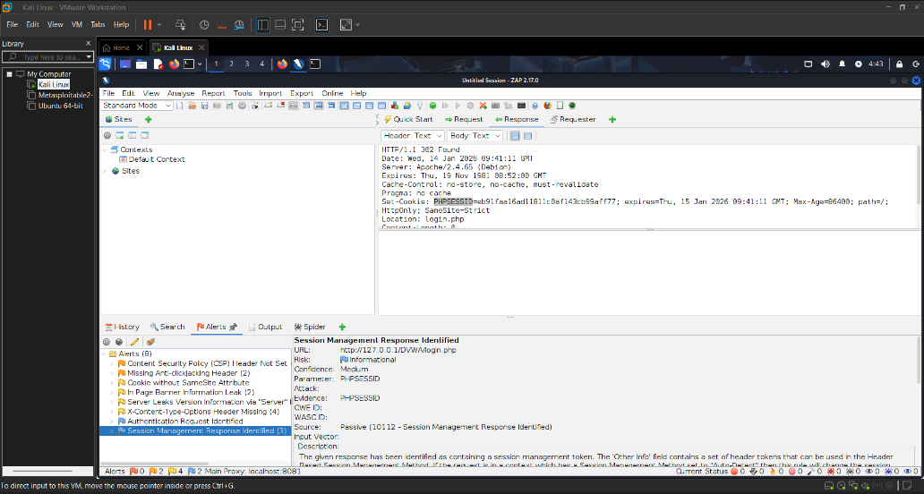

9. Summary
The DVWA web application was tested using Burp Suite and sqlmap to identify OWASP Top 10 vulnerabilities. Critical SQL injection and reflected XSS flaws were discovered through automated and manual testing. Weak authentication and session management further increased security risks, demonstrating the importance of secure coding practices.

